Gender & Sexuality Studies
  - Semesters 1 & 2, 2021-22

Module overview
This module offers an introduction to key issues in gender and sexuality studies. It is not a module about feminism, per se, nor does it provide a history of the women’s rights movement or women’s writing. Instead, it uses a mix of feminist, queer, and postcolonial theory and philosophy written primarily in Britain and North America to read a variety of modern and contemporary literary and visual texts, written from a range of gendered identities. We will discuss how gender and sexuality are significant themes in a variety of cultural forms but primarily our classes will interrogate how texts represent, challenge, complicate, and in some cases reinforce simplistic notions of our bodily and sexual lives.

Methodology and approach
Our approach to gender and sexuality studies is non-binary, decolonial, anti-racist, and ‘intersectional’; four complicated and capacious terms that you will learn more about in Semester 1.

This means that we see gender and sexuality as a series of socially constructed categories that intersect and overlap with other characteristics like race, class, religion, nationality, and ability to make up experiences of inequality. All four terms are better conceived as frameworks rather than positions: throughout the course, we hope to model ways in which gender and sexuality studies must be actively and repeatedly reframed and interrogated to decentre colonialism, white supremacy, and gender determinism and, as Lola Olufemi writes, to use theory to imagine a more hopeful future.

Key topics
Over the year, the course will introduce the following ideas and themes:
- Contemporary and mainstream feminisms;
- Social concepts of gender, sex, and sexuality;
- Histories of Black feminism in the United States;
- Intersectionality;
- Gender and sexuality as constructs and tools of colonialism;
- LGBTQIA+ identities and queer theory;
- Compulsory heterosexuality and heteronormativity;
- Camp, ‘bad’ taste, and kitsch aesthetics;
- Disability studies and queer approaches to body politics.

Course outline: Semester 1

Week 1: Introduction
Seminar reading: A selection of poems by women and queer poets, which may include:
- Sappho, 'The Anactoria Poem' - fragment 16 (6th century BC)
- Aphra Behn, 'The Dream' (late 1600s)
- Frank O'Hara, 'Mayakovsky' (1967)
- June Jordan, 'The Talking Back of Miss Valentine Jones: Poem # one' (1969)
- Audre Lorde - 'Recreation' (1997)
- Ocean Vuong - ‘Home Wrecker’ (2012)
- Joshua Jennifer Espinoza - ‘The Moon is Trans’ (2015) - once you've followed the link, scroll to the bottom of the page

Sample seminar prep:
Read all the poems listed above. Think through the following questions:
- How does the author portray ideas of gender and/or sexuality? Within the broader themes of gender and sexuality, what sub-themes do these poems represent? i.e. experiences of discrimination (misogyny, racism, ableism, etc.), gendered and sexual binaries, gender and sexual fluidity, romantic and platonic love, social class, body politics and embodied sensation/experience, etc.
- Can you identify any key literary techniques that these writers use to represent themes of gender and/or sexuality? Or, how do these writers use poetic techniques to express what it feels like to be gendered, to have sexuality?

Week 2: Introduction
Seminar reading: Lola Olufemi, Feminism, Interrupted: Disrupting Power (2020)
Content note: Olufemi's text surveys a range of issues in contemporary feminism and includes critique and therefore vivid accounts of racism, transphobia, Islamophobia, sexual violence, fat phobia, and eating disorders.
Sample seminar preparation:
- Read Feminism, Interrupted in full, keeping a log of the key points and any queries/points of disagreement. Were there any details/ideas that particularly surprised you, that were new to you? How can you link her ideas to the reading from Week 1?
Lola Olufemi in 2020
- What does Olufemi say the difference is between what feminism is and what it should do? What are their most persuasive arguments for change?

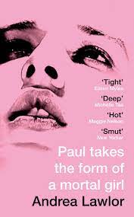
Week 3: What is gender? What is sex?
Seminar reading: Andrea Lawlor, Paul Takes the Form of a Mortal Girl (2017/2019)
Content note: There is a lot of sex in this novel - not a trigger, per se, but something to be aware of! The novel also features an instance of sexual assault and instances of/allusions to transphobia.

Sample seminar preparation:
- The novel's plot revolves around Paul's ability to change both gender and sex, not only undercutting the idea of gendered and sexed binaries but also questioning the centrality of gender to queer subcultures. What does Paul's ability allow him to do? What kind of subcultures is he able to occupy as a result of this ability? What are the most interesting things he uses his ability to do/challenge?
- Sex is a famously difficult thing to write about - you only need to look at the entries for the Bad Sex in Fiction award to see the many ways in which it make sex seem terrible. What do you think of the way that Lawlor writes Paul's sex scenes? What function does sex have in the narrative, i.e. why is it so important? What is the relationship between gender and sex (as concepts) and sexuality in the novel?

Week 4: What is gender? What is sex?
Seminar reading: Judith Butler, ‘Performative Acts and Gender Constitution: An Essay in Phenomenological and Feminist Theory’, Theatre Journal (1988), 519-531
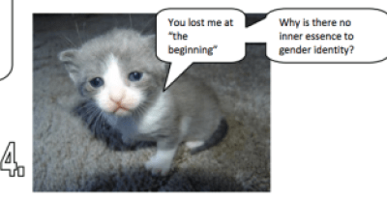
Content note: Butler’s arguments are sometimes used by trans-exclusionary feminists, although it should be noted that she rejects their arguments. Anyone interested in reading some of Butler's more recent thoughts on gender and sex should read her interview with the New Statesman here.

Sample seminar preparation:
- How would you sum up Butler's basic argument about the "doing" of gender? Can you think of any examples? How convincing do you find this as a theory? What are Butler's reasons for it, i.e. why do we "do" gender?
‘Judith Butler Explained With Cats’ (click on picture for link)
- Butler makes a number of interesting claims about the body in relation to history and culture. What does she mean when she writes: "the body is a historical situation [...] and is a manner of doing, dramatizing, and reproducing a historical situation" (521)?
- How might we read Paul and his experience of gender in Paul Takes the Form of a Mortal Girl through this quote? In what ways does Lawlor portray him and his experience of his body as "a historical situation"?

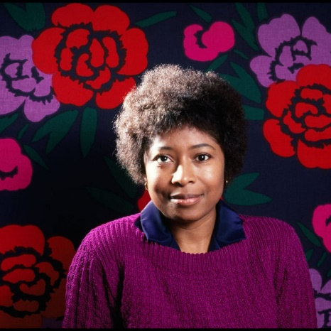
Week 5: Womanism and Black feminisms
Seminar reading: Alice Walker, Meridian (1976)
Content note: Sexual violence, including one instance of rape and casual references to sexual harassment; racism and racial violence; anti-Semitism; accounts of suicidal ideation.

Sample seminar preparation:
- Consider the way that oppressions and experiences intersect in Meridian. What moments in the novel best demonstrate the overlap of gender, race, class, sexuality, ability, etc.? What scenes reveal the particular oppressions of Black women in America?
Alice Walker in 1982
- Compare and contrast the characters of Meridian, Anne-Marion, and Lynne. What happens to each of them and how is their experience of the same events different? How does their involvement with the civil rights movement affect them personally? What are their motivations for getting involved?

Week 7: Womanism and Black feminisms
Seminar reading:
- 'The Combahee River Collective Statement' (originally published 1977), Monthly Review Vol. 70, Issue 8, (Jan 2019): 29-36
- Alice Walker, 'Womanist' (1983), The Womanist Reader: The First Quarter Century of Womanist Thought, edited by Layli Phillips (London: Taylor & Francis Group, 2006): 19
- Audre Lorde, ‘The Master’s Tools Will Never Dismantle the Master's House’ (1984), in Your Silence Will Not Protect You (London: Silver Press, 2017)

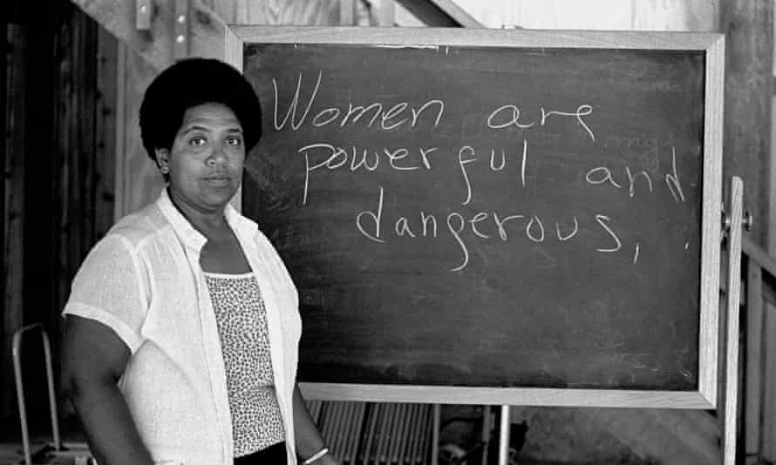
All PDFs will be available on Canvas, but if you want to get ahead there are fairly accurate, unofficial copies online.

Seminar preparation:
- What are the key issues and demands of the CRC, Walker, and Lorde? Are there similarities, or differences? What traditions do they situate themselves within? What kind of language do they use? What audience do they write for?
Audre Lorde in 1983
- How do the ideas expressed in Alice Walker's 'Womanism' relate to our discussion of Meridian last week? How might we apply the other essays - by the CRC and Lorde - to the novel? What significance might terms and frameworks like identity politics and intersecting oppressions have to an analysis of the novel, or any other text studied this term?

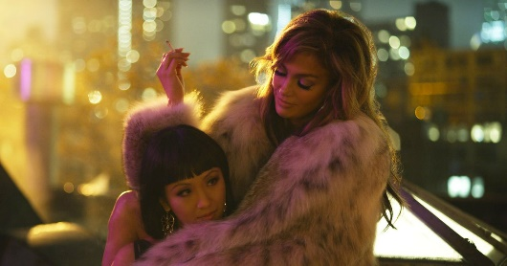
Week 8: Intersectionality
Seminar viewing:
- Hustlers (2019; film), directed by Lorene Scarfaria

Sample seminar preparation:
- Hustlers is a film about stripping that highlights themes of gender and sexuality in the financial sector and mainstream popular culture in the mid-00s. What are your initial observations about the way women are portrayed in the film? How are relationships between women portrayed? How are their differences – in body, race, finance, psychology, sexuality, romance, etc. – represented?
- Many reviewers claim that Hustlers ‘weaponizes the female gaze,’ depicting the power of women’s bodies without objectifying or fetishizing them to highlight the skill and work of sex work. Using evidence from the film, do you agree or disagree with this statement? How does the film encourage us to look at the dancers and women’s bodies? How is this affected by bodily difference (race, size, age, ability)?

Week 9: Intersectionality
Seminar reading:
- Extract from Kimberlé Crenshaw, ‘Mapping the Margins: Intersectionality, Identity Politics, and Violence against Women of Color,’ Stanford Law Review 43.6 (1991): 1241-1299.
- Patricia Hill Collins and Sirma Bilge, ‘What is Intersectionality?,’ in Intersectionality (Cambridge: Polity Press, 2020): 14-38.
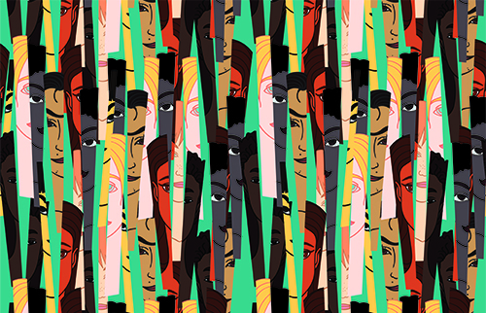
Sample seminar preparation:
Drawing on this week’s readings, how would you define intersectionality? You might answer this question in the following ways:
- Write your own dictionary definition – you might include examples from the readings or differentiate between intersectionality, intersectional analysis/praxis, and intersectional politics.
- Write a brief summary of how this week’s reading compares to your existing or common ideas of intersectionality. How is intersectionality commonly used or misused? What are the main differences between common conceptions of intersectionality and the ways that Crenshaw, Hill Collins, and Bilge use the term? You might include a list of any detail in the reading that was new or surprising to you.
- Write your own example of an intersectional analysis using any of the texts studied this term. How might you apply the theories of intersectionality to a literary or visual text? Why is intersectional analysis important? Why is it more complex than is commonly understood?
- Describe the intellectual through line from Alice Walker, Audre Lorde, and the Combahee River Collective to Crenshaw, Hill Collins, Bilge, and intersectionality? How is intersectionality a different but complementary term to the CRC’s use of “interlocking” oppressions?

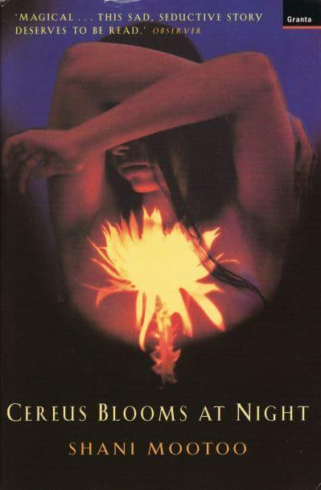
Week 10: Gender and colonialism
Seminar reading:
- Shani Mootoo, Cereus Blooms at Night (1999)
Content note: The novel is shaped by colonial and racist violence and, through central characters, features instances of sexual violence - against both adults and children - and homophobia.

Sample seminar preparation:
- The novel presents an uncovering of the secrets and lies of a community which everyone already knows, or half-knows, but can’t or won’t speak. How is speaking/silence represented in the novel? How are the resistances to knowing and remembering represented?
- What are the ‘nervous conditions’ suffered by each of the chief characters? Are they gendered? How are these associated with poverty, colonialism, or the situation of ‘being modern’? Is being ‘hybrid’ an unavoidable element of living in a colonial situation?

Week 11: Gender and colonialism
Seminar reading:
- Extracts from b. binaohan, decolonising trans/gender 101 (2014)

A full PDF will be provided: if you find yourself short on time, please focus on Part 1: Introduction, Part 2 (including 2.1 and 2.2): What is 'transgender'?, Part 5 (including 5.1, 5.2, and 5.3): the (white) history of transgenderism and its evolution (in modern times), and Part 6 (including 6.1 and 6.2): the pathology of being transgender.

Sample seminar preparation:
- Drawing on last week’s lecture and the reading for this week, how do you understand what Maria Lugones refers to as the ‘coloniality of gender’? In what ways is gender colonial? How is the gender binary exemplary of colonial structures/hierarchies?
- “[I]t is impossible to talk about the history of transgender with no explicit mention of colonialism or race” (binaohan). How do you make sense of this statement? What examples does binaohan give in decolonizing trans/gender 101?
- Now that you’ve read binaohan, how might we apply their arguments to Cereus Blooms at Night? How, for instance, does the novel represent ‘nature’ (broadly speaking), categories, genders, and sexualities?

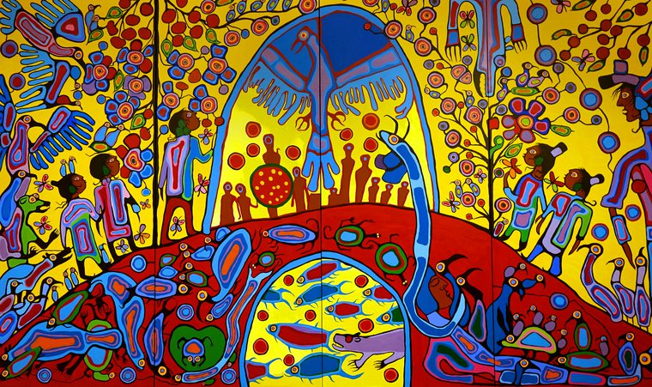
'Androgyny' by Anishinaabe painter Norval Morrisseau, Ottawa, Canada (2017)

